**What is SAP?**

**Sap is ERP software.**

**What is ERP?**

**-Enterprise resources planning. For integration the business process.**

**-Standardization of system across locations**

**-For overall control of Organizations.**

**-Better Controlling of different business processes.**

**-Best utilization of resources i.e., Man, Material& machines**

**ERP Products in the Market**

**-SAP -------more than 60 % market share**

**-Oracle**

**-BAAN**

**-People soft**

**-JD Edwards**

**-Marshall**

**What is SAP?**

**-Systems Applications and Products in data Processing.**

**-Realtime example: retails, automobiles**

**-four largest s/w company in the world.**

**-The SAP R/3 system is a business software package designed to integrate all areas of a business.**

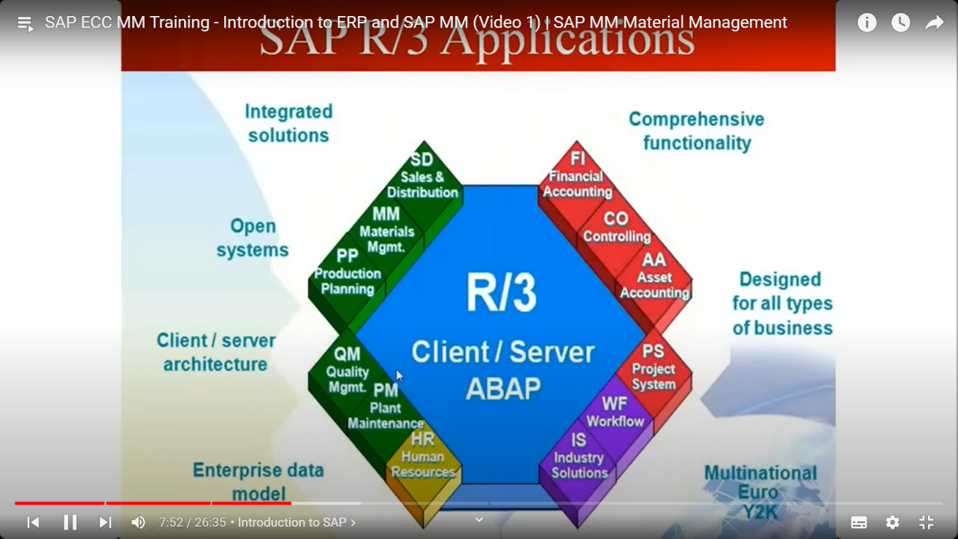

**What is different modulus of SAP?**

**-Functional Modules**

**-Technical Module**

**FUNCTIONAL MODULUS**

**-FI (Financial Planning)**

**-CO (Controlling)**

**-HR (Human Resources)**

**-SD (Sales & Distribution)**

**-MM (Material Management)**

**-CRM (Customer Relationship mgt)**

**Technical Modulus**

**-**

**SAP classical implementation landscape**

**-Development System**

**- QAS/Testing system**

**-SAP production /live system**